Chapter 3: Discrete Random Variables and Their Probability Distributions

  - P(Y = 0) = P(no impurities) = .2, P(Y = 1) = P(exactly one impurity) = .7, P(Y = 2) = .1.

  - We know that P(HH) = P(TT) = P(HT) = P(TH) = 0.25. So, P(Y = -1) = .5, P(Y = 1) = .25 = P(Y = 2).

  - p(2) = P(DD) = 1/6, p(3) = P(DGD) + P(GDD) = 2(2/4)(2/3)(1/2) = 2/6, p(4) = P(GGDD) + P(DGGD) + P(GDGD) = 3(2/4)(1/3)(2/2) = 1/2.

  - Define the events: A: value 1 fails B: valve 2 fails C: valve 3 fails
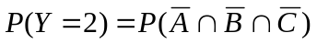 = .8³ = 0.512
= .2(.2 + .2 - .2²) = 0.072.
Thus, P(Y = 1) = 1 - .512 - .072 = 0.416.

  - There are 3! = 6 possible ways to assign the words to the pictures. Of these, one is a perfect match, three have one match, and two have zero matches. Thus,
p(0) = 2/6, p(1) = 3/6, p(3) = 1/6.

  - There are 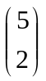 = 10 sample points, and all are equally likely: (1,2), (1,3), (1,4), (1,5), (2,3), (2,4), (2,5), (3,4), (3,5), (4,5).
- p(2) = .1, p(3) = .2, p(4) = .3, p(5) = .4.

- p(3) = .1, p(4) = .1, p(5) = .2, p(6) = .2, p(7) = .2, p(8) = .1, p(9) = .1.

  - There are 3³ = 27 ways to place the three balls into the three bowls. Let Y = # of empty bowls. Then:
p(0) = P(no bowls are empty) = 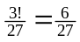
p(2) = P(2 bowls are empty) = 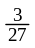
p(1) = P(1 bowl is empty) = 1 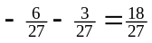.

  - Note that the number of cells cannot be odd.
p(0) = P(no cells in the next generation) = P(the first cell dies or the first cell splits and both die) = .1 + .9(.1)(.1) = 0.109
p(4) = P(four cells in the next generation) = P(the first cell splits and both created cells split) = .9(.9)(.9) = 0.729.
p(2) = 1 – .109 – .729 = 0.162.

  - The random variable Y takes on vales 0, 1, 2, and 3.
a. Let E denote an error on a single entry and let N denote no error. There are 8 sample points: EEE, EEN, ENE, NEE, ENN, NEN, NNE, NNN. With P(E) = .05 and P(N) = .95 and assuming independence:
P(Y = 3) = (.05)³ = 0.000125 P(Y = 2) = 3(.05)2(.95) = 0.007125
P(Y = 1) = 3(.05)²(.95) = 0.135375 P(Y = 0) = (.95)³ = 0.857375.
b. The graph is omitted.
c. P(Y > 1) = P(Y = 2) + P(Y = 3) = 0.00725.

  - Denote R as the event a rental occurs on a given day and N denotes no rental. Thus, the sequence of interest is RR, RNR, RNNR, RNNNR, … . Consider the position immediately following the first R: it is filled by an R with probability .2 and by an N with probability .8. Thus, P(Y = 0) = .2, P(Y = 1) = .8(.2) = .16, P(Y = 2) = .128, … . In general,
P(Y = y) = .2(.8)^{y}, y = 0, 1, 2, … .

  - There is a 1/3 chance a person has O⁺ blood and 2/3 they do not. Similarly, there is a 1/15 chance a person has O– blood and 14/15 chance they do not. Assuming the donors are randomly selected, if X = # of O⁺ blood donors and Y = # of O– blood donors, the probability distributions are

 | 0 | 1 | 2 | 3
p(x) | (2/3)³ = 8/27 | 3(2/3)²(1/3) = 12/27 | 3(2/3)(1/3)² =6/27 | (1/3)³ = 1/27
p(y) | 2744/3375 | 196/3375 | 14/3375 | 1/3375

Note that Z = X + Y = # will type O blood. The probability a donor will have type O blood is 1/3 + 1/15 = 6/15 = 2/5. The probability distribution for Z is

 | 0 | 1 | 2 | 3
p(z) | (2/5)³ = 27/125 | 3(2/5)²(3/5) = 54/27 | 3(2/5)(3/5)² =36/125 | (3/5)³ = 27/125

  - E(Y) = 1(.4) + 2(.3) + 3(.2) + 4(.1) = 2.0
E(1/Y) = 1(.4) + 1/2(.3) + 1/3(.2) + 1/4(.1) = 0.6417
E(Y² – 1) = E(Y²) – 1 = [1(.4) + 2²(.3) + 3²(.2) + 4²(.1)] – 1 = 5 – 1 = 4.
V(Y) = E(Y²) = [E(Y)]² = 5 – 22 = 1.

  - E(Y) = –1(1/2) + 1(1/4) + 2(1/4) = 1/4
E(Y²) = (–1)²(1/2) + 1²(1/4) + 2²(1/4) = 7/4
V(Y) = 7/4 – (1/4)² = 27/16.
Let C = cost of play, then the net winnings is Y – C. If E(Y – C) = 0, C = 1/4.

  - a. μ = E(Y) = 3(.03) + 4(.05) + 5(.07) + … + 13(.01) = 7.9
b. σ² = V(Y) = E(Y²) – [E(Y)]² = 3²(.03) + 4²(.05) + 5²(.07) + … + 13²(.01) – 7.9² = 67.14 – 62.41 = 4.73. So, σ = 2.17.
c. (μ – 2σ, μ + 2σ) = (3.56, 12.24). So, P(3.56 < Y < 12.24) = P(4 ≤ Y ≤ 12) = .05 + .07 + .10 + .14 + .20 + .18 + .12 + .07 + .03 = 0.96.

  - a. p(0) = P(Y = 0) = (.48)³ = .1106, p(1) = P(Y = 1) = 3(.48)²(.52) = .3594, p(2) = P(Y = 2) = 3(.48)(.52)² = .3894, p(3) = P(Y = 3) = (.52)³ = .1406.
b. The graph is omitted.
c. P(Y = 1) = .3594.

d. μ = E(Y) = 0(.1106) + 1(.3594) + 2(.3894) + 3(.1406) = 1.56,
σ² = V(Y) = E(Y²) –[E(Y)]² = 0²(.1106) + 1²(.3594) + 2²(.3894) + 3²(.1406) – 1.56² = 3.1824 – 2.4336 = .7488. So, σ = 0.8653.
e. (μ – 2σ, μ + 2σ) = (–.1706, 3.2906). So, P(–.1706 < Y < 3.2906) = P(0 ≤ Y ≤ 3) = 1.
  - As shown in Ex. 2.121, P(Y = y) = 1/n for y = 1, 2, …, n. Thus, E(Y) = 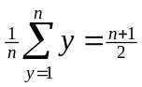.
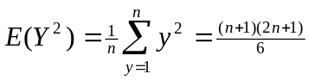. So, 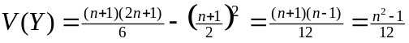.

  - μ = E(Y) = 0(6/27) + 1(18/27) + 2(3/27) = 24/27 = .889
σ² = V(Y) = E(Y²) –[E(Y)]² = 0²(6/27) + 1²(18/27) + 2²(3/27) – (24/27)² = 30/27 – 576/729 = .321. So, σ = 0.567
For (μ – 2σ, μ + 2σ) = (–.245, 2.023). So, P(–.245 < Y < 2.023) = P(0 ≤ Y ≤ 2) = 1.

  - μ = E(Y) = 0(.109) + 2(.162) + 4(.729) = 3.24.

  - Let P be a random variable that represents the company’s profit. Then, P = C – 15 with probability 98/100 and P = C – 15 – 1000 with probability 2/100. Then,
E(P) = (C – 15)(98/100) + (C – 15 – 1000)(2/100) = 50. Thus, C = $85.

  - With probability .3 the volume is 8(10)(30) = 2400. With probability .7 the volume is 8*10*40 = 3200. Then, the mean is .3(2400) + .7(3200) = 2960.

  - Note that E(N) = E(8πR²) = 8πE(R²). So, E(R²) = 21²(.05) + 22²(.20) + … + 26²(.05) = 549.1. Therefore E(N) = 8π(549.1) = 13,800.388.

  - Note that p(y) = P(Y = y) = 1/6 for y = 1, 2, …, 6. This is similar to Ex. 3.16 with n = 6. So, E(Y) = 3.5 and V(Y) = 2.9167.

  - Define G to be the gain to a person in drawing one card. The possible values for G are $15, $5, or $–4 with probabilities 3/13, 2/13, and 9/13 respectively. So,
E(G) = 15(3/13) + 5(2/13) – 4(9/13) = 4/13 (roughly $.31).

  - The probability distribution for Y = number of bottles with serious flaws is:
p(y) | 0 | 1 | 2
y | .81 | .18 | .01

Thus, E(Y) = 0(.81) + 1(.18) + 2(.01) = 0.20 and V(Y) = 0²(.81) + 1²(.18) + 2²(.01) – (.20)² = 0.18.

  - Let X₁ = # of contracts assigned to firm 1; X₂ = # of contracts assigned to firm 2. The sample space for the experiment is {(I,I), (I,II), (I,III), (II,I), (II,II), (II,III), (III,I), (III,II), (III,III)}, each with probability 1/9. So, the probability distributions for X₁ and X₂ are:
x₁ | 0 | 1 | 2 |  | x₂ | 0 | 1 | 2
p(x₁) | 4/9 | 4/9 | 1/9 |  | p(x₂) | 4/9 | 4/9 | 1/9

Thus, E(X₁) = E(X₂) = 2/3. The expected profit for the owner of both firms is given by
90000(2/3 + 2/3) = $120,000.

  - The random variable Y = daily sales can have values $0, $50,000 and $100,000.
If Y = 0, either the salesperson contacted only one customer and failed to make a sale or the salesperson contacted two customers and failed to make both sales. Thus P(Y = 0) = 1/3(9/10) + 2/3(9/10)(9/10) = 252/300.
If Y = 2, the salesperson contacted to customers and made both sales. So, P(Y = 2) = 2/3(1/10)(1/10) = 2/300.
Therefore, P(Y = 1) = 1 – 252/300 – 2/300 = 46/300.
Then, E(Y) = 0(252/300) + 50000(46/300) + 100000(2/300) = 25000/3 (or $8333.33).
V(Y) =380,561,111 and σ = $19,507.98.

  - Let Y = the payout on an individual policy. Then, P(Y = 85,000) = .001, P(Y = 42,500) = .01, and P(Y = 0) = .989. Let C represent the premium the insurance company charges. Then, the company’s net gain/loss is given by C – Y. If E(C – Y) = 0, E(Y) = C. Thus,
E(Y) = 85000(.001) + 42500(.01) + 0(.989) = 510 = C.

  - Using the probability distribution found in Ex. 3.3, E(Y) = 2(1/6) + 3(2/6) + 4(3/6) = 20/6. The cost for testing and repairing is given by 2Y + 4. So, E(2Y + 4) = 2(20/6) + 4 = 64/6.

  - a. The mean of X will be larger than the mean of Y.
b. E(X) = E(Y + 1) = E(Y) + 1 = μ + 1.
c. The variances of X and Y will be the same (the addition of 1 doesn’t affect variability).
d. V(X) = E[(X – E(X))²] = E[(Y + 1 – μ – 1)²] = E[(Y – μ)²] = σ².

  - a. The mean of W will be larger than the mean of Y if μ > 0. If μ < 0, the mean of W will be smaller than μ. If μ = 0, the mean of W will equal μ.
b. E(W) = E(2Y) = 2E(Y) = 2μ.
c. The variance of W will be larger than σ², since the spread of values of W has increased.
d. V(X) = E[(X – E(X))²] = E[(2Y – 2μ)²] = 4E[(Y – μ)²] = 4σ².

3.32 a. The mean of W will be smaller than the mean of Y if μ > 0. If μ < 0, the mean of W will be larger than μ. If μ = 0, the mean of W will equal μ.
b. E(W) = E(Y/10) = (.1)E(Y) = (.1)μ.
c. The variance of W will be smaller than σ², since the spread of values of W has decreased.
d. V(X) = E[(X – E(X))²] = E[(.1Y – .1μ)²] = (.01)E[(Y – μ)²] = (.01)σ².

  - a.
b.

  - The mean cost is E(10Y) = 10E(Y) = 10[0(.1) + 1(.5) + 2(.4)] = $13. Since V(Y) .41, V(10Y) = 100V(Y) = 100(.41) = 41.

  - With 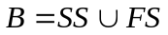, P(B) = P(SS) + P(FS) = 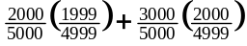 = 0.4
P(B|first trial success) = 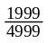 = 0.3999, which is not very different from the above.

  - a. The random variable Y does not have a binomial distribution. The days are not independent.
b. This is not a binomial experiment. The number of trials is not fixed.

  - a. Not a binomial random variable.
b. Not a binomial random variable.
c. Binomial with n = 100, p = proportion of high school students who scored above 1026.
d. Not a binomial random variable (not discrete).
e. Not binomial, since the sample was not selected among all female HS grads.

  - Note that Y is binomial with n = 4, p = 1/3 = P(judge chooses formula B).
- p(y) = 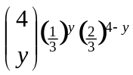, y = 0, 1, 2, 3, 4.
- P(Y ≥ 3) = p(3) + p(4) = 8/81 + 1/81 = 9/81 = 1/9.
- E(Y) = 4(1/3) = 4/3.
- V(Y) = 4(1/3)(2/3) = 8/9

  - Let Y = # of components failing in less than 1000 hours. Then, Y is binomial with n = 4 and p = .2.
- P(Y = 2) = 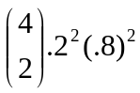 = 0.1536.
- The system will operate if 0, 1, or 2 components fail in less than 1000 hours. So, P(system operates) = .4096 + .4096 + .1536 = .9728.

  - Let Y = # that recover from stomach disease. Then, Y is binomial with n = 20 and p = .8. To find these probabilities, Table 1 in Appendix III will be used.
- P(Y ≥ 10) = 1 – P(Y ≤ 9) = 1 – .001 = .999.
- P(14 ≤ Y ≤ 18) = P(Y ≤ 18) – P(Y ≤ 13) – .931 – .087 = .844
- P(Y ≤ 16) = .589.

  - Let Y = # of correct answers. Then, Y is binomial with n = 15 and p = .2. Using Table 1 in Appendix III, P(Y ≥ 10) = 1 – P(Y ≤ 9) = 1 – 1.000 = 0.000 (to three decimal places).

  - a. If one answer can be eliminated on every problem, then, Y is binomial with n = 15 and p = .25. Then, P(Y ≥ 10) = 1 – P(Y ≤ 9) = 1 – 1.000 = 0.000 (to three decimal places).

b. If two answers can be (correctly) eliminated on every problem, then, Y is binomial with n = 15 and p = 1/3. Then, P(Y ≥ 10) = 1 – P(Y ≤ 9) = 0.0085.

  - Let Y = # of qualifying subscribers. Then, Y is binomial with n = 5 and p = .7.
- P(Y = 5) = .7⁵ = .1681
- P(Y ≥ 4) = P(Y = 4) + P(Y = 5) = 5(.7⁴)(.3) + .7⁵ = .3601 + .1681 = 0.5282.

  - Let Y = # of successful operations. Then Y is binomial with n = 5.
- With p = .8, P(Y = 5) = .8⁵ = 0.328.
- With p = .6, P(Y = 4) = 5(.6⁴)(.4) = 0.259.
- With p = .3, P(Y < 2) = P(Y = 1) + P(Y = 0) = 0.528.

  - Note that Y is binomial with n = 3 and p = .8. The alarm will function if Y = 1, 2, or 3. Thus, P(Y ≥ 1) = 1 – P(Y = 0) = 1 – .008 = 0.992.

  - When p = .5, the distribution is symmetric. When p < .5, the distribution is skewed to the left. When p > .5, the distribution is skewed to the right.

  - The graph is above. 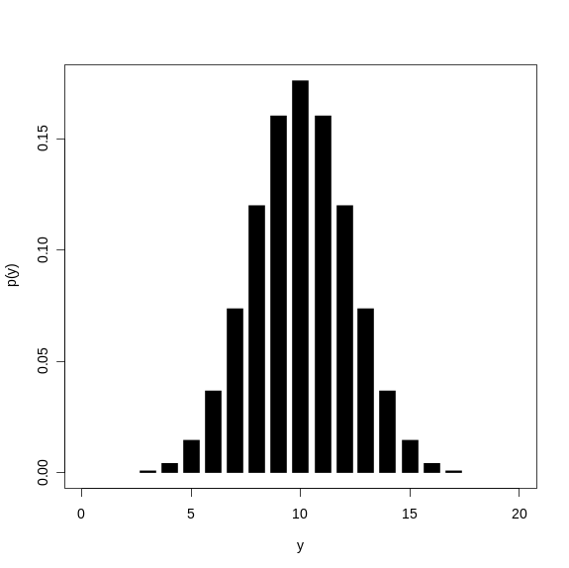

  - a. Let Y = # of sets that detect the missile. Then, Y has a binomial distribution with n = 5 and p = .9. Then, P(Y = 4) = 5(.9)⁴(.1) = 0.32805 and
P(Y ≥ 1) = 1 – P(Y = 0) = 1 – 5(.9)⁴(.1) = 0.32805.
b. With n radar sets, the probability of at least one diction is 1 – (.1)^{n}. If 1 – (.1)^{n} = .999, n = 3.

  - Let Y = # of housewives preferring brand A. Thus, Y is binomial with n = 15 and p = .5.
- Using the Appendix, P(Y ≥ 10) = 1 – P(Y ≤ 9) = 1 – .849 = 0.151.
- P(10 or more prefer A or B) = P(6 ≤ Y ≤ 9) = 0.302.
  - The only way team A can win in exactly 5 games is to win 3 in the first 4 games and then win the 5th game. Let Y = # of games team A wins in the first 4 games. Thus, Y has a binomial distribution with n = 4. Thus, the desired probability is given by
P(Team A wins in 5 games) = P(Y = 3)P(Team A wins game 5)
= 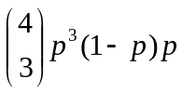 = 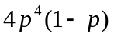.

  - a. P(at least one 6 in four rolls) = 1 – P(no 6’s in four rolls) = 1 – (5/6)⁴ = 0.51775.

b. Note that in a single toss of two dice, P(double 6) = 1/36. Then:
P(at least one double 6 in twenty–four rolls) = 1 – P(no double 6’s in twenty–four rolls) = = 1 – (35/36)²⁴ = 0.4914.

  - Let Y = # that are tasters. Then, Y is binomial with n = 20 and p = .7.
- P(Y ≥ 17) = 1 – P(Y ≤ 16) = 0.107.
- P(Y < 15) = P(Y ≤ 14) = 0.584.

  - There is a 25% chance the offspring of the parents will develop the disease. Then, Y = # of offspring that develop the disease is binomial with n = 3 and p =.25.
- P(Y = 3) = (.25)³ = 0.015625.
- P(Y = 1) = 3(.25)(.75)² = 0.421875
- Since the pregnancies are mutually independent, the probability is simply 25%.

  - a. and b. follow from simple substitution
c. the classifications of “success” and “failure” are arbitrary.

= 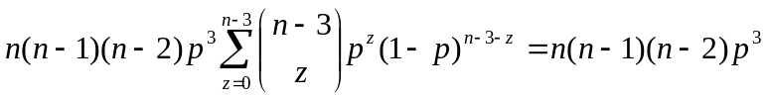 .
Equating this to E(Y³) – 3E(Y²) + 2E(Y), it is found that
E(Y³) = 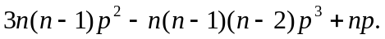

  - Using expression for the mean and variance of Y = # of successful explorations, a binomial random variable with n = 10 and p = .1, E(Y) = 10(.1) = 1, and
V(Y) = 10(.1)(.9) = 0.9.

  - If Y = # of successful explorations, then 10 – Y is the number of unsuccessful explorations. Hence, the cost C is given by C = 20,000 + 30,000Y + 15,000(10 – Y). Therefore, E(C) = 20,000 + 30,000(1) + 15,000(10 – 1) = $185,000.

  - If Y is binomial with n = 4 and p = .1, E(Y) = .4 and V(Y) = .36. Thus, E(Y²) = .36 + (.4)² = 0.52. Therefore, E(C) = 3(.52) + (.36) + 2 = 3.96.
  - If Y = # of defective motors, then Y is binomial with n = 10 and p = .08. Then, E(Y) = .8. The seller’s expected next gain is $1000 – $200E(Y) = $840.

  - Let Y = # of fish that survive. Then, Y is binomial with n = 20 and p = .8.
- P(Y = 14) = .109.
- P(Y ≥ 10) = .999.
- P(Y ≤ 16) = .589.
- μ = 20(.8) = 16, σ² = 20(.8)(.2) = 3.2.

  - Let Y = # with Rh⁺ blood. Then, Y is binomial with n = 5 and p = .8
- 1 – P(Y = 5) = .672.
- P(Y ≤ 4) = .672.
- We need n for which P(Y ≥ 5) = 1 – P(Y ≤ 4) > .9. The smallest n is 8.

  - a. Assume independence of the three inspection events.
b. Let Y = # of plane with wing cracks that are detected. Then, Y is binomial with n = 3 and p = .9(.8)(.5) = .36. Then, P(Y ≥ 1) = 1 – P(Y = 0) = 0.737856.

  - a. Found by pulling in the formula for p(y) and p(y – 1) and simplifying.

b. Note that P(Y < 3) = P(Y ≤ 2) = P(Y = 2) + P(Y = 1) + P(Y = 0). Now, P(Y = 0) = (.96)⁹⁰ = .0254. Then, P(Y = 1) = 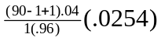 = .0952 and P(Y = 2) = 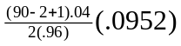 = .1765. Thus, P(Y < 3) = .0254 + .0952 + .1765 = 0.2971

c. 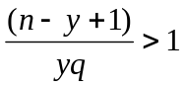 is equivalent to 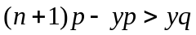 is equivalent to 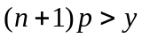. The others are similar.

d. Since for y ≤ (n + 1)p, then p(y) ≥ p(y – 1) > p(y – 2) > … . Also, for y ≥ (n + 1)p, then p(y) ≥ p(y + 1) > p(y + 2) > … . It is clear that p(y) is maximized when y is a close to
(n + 1)p as possible.

  - To maximize the probability distribution as a function of p, consider taking the natural log (since ln() is a strictly increasing function, it will not change the maximum). By taking the first derivative of ln[p(y₀)] and setting it equal to 0, the maximum is found to be y₀/n.

  - a. E(Y/n) = E(Y)/n = np/n = p.
b. V(Y/n) = V(Y)/n² = npq/n² = pq/n. This quantity goes to zero as n goes to infinity.

  - a. 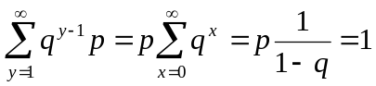 (infinite sum of a geometric series)
b. 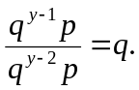 The event Y = 1 has the highest probability for all p, 0 < p < 1.

  - (.7)⁴(.3) = 0.07203.

  - 1/(.30) = 3.33.

  - Y is geometric with p = 1 – .41 = .59. Thus,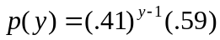, y = 1, 2, … .

  - Let Y = # of holes drilled until a productive well is found.
- P(Y = 3) = (.8)²(.2) = .128
- P(Y > 10) = P(first 10 are not productive) = (.8)¹⁰ = .107.

  - a. 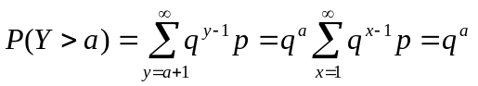.
b. From part a, 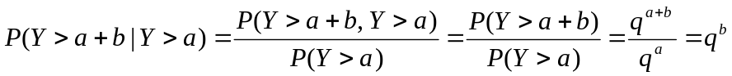.

c. The results in the past are not relevant to a future outcome (independent trials).

  - Let Y = # of tosses until the first head. P(Y ≥ 12 | Y > 10) = P(Y > 11 | Y > 10) = 1/2.

  - Let Y = # of accounts audited until the first with substantial errors is found.
- P(Y = 3) = .1²(.9) = .009.
- P(Y ≥ 3) = P(Y > 2) = .1² = .01.

  - μ = 1/.9 = 1.1, σ = 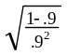 = .35

  - Let Y = # of one second intervals until the first arrival, so that p = .1
- P(Y = 3) = (.9)2(.1) = .081.
- P(Y ≥ 3) = P(Y > 2) = .9² = .81.

  - 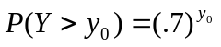≥ .1. Thus, y₀ ≤ 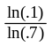 = 6.46, so y₀ ≤ = 6.

  - P(Y = 1, 3, 5, …) = P(Y = 1) + P(Y + 3) + P(Y = 5) + … = p + q²p + q⁴p + … =
p[1 + q² + q⁴ + …] = 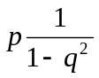. (Sum an infinite geometric series in 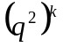.)

  - a. (.4)⁴(.6) = .01536.
b. (.4)⁴ = .0256.

  - Let Y = # of people questioned before a “yes” answer is given. Then, Y has a geometric distribution with p = P(yes) = P(smoker and “yes”) + P(nonsmoker and “yes”) = .3(.2) + 0 = .06. Thus, p(y) = .06(.94)^{y–1}. y = 1, 2, … .

  - Let Y = # of tosses until the first 6 appears, so Y has a geometric distribution. Using the result from Ex. 3.77,
P(B tosses first 6) = P(Y = 2, 4, 6, …) = 1 – P(Y = 1, 3, 5, …) = 1 – .
Since p = 1/6, P(B tosses first 6) = 5/11. Then,
P(Y = 4 | B tosses the first 6) 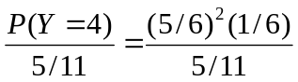 = 275/1296.

  - With p = 1/2, then μ = 1/(1/2) = 2.

  - With p = .2, then μ = 1/(.2) = 5. The 5th attempt is the expected first successful well.

  - Let Y = # of trials until the correct password is picked. Then, Y has a geometric distribution with p = 1/n. P(Y = 6) = 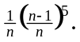

  - E(Y) = n, V(Y) = 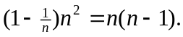

  - Note that 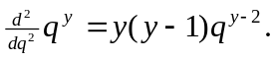 Thus, 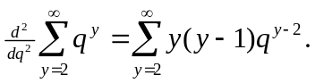 Thus,
E[Y(Y–1)] = 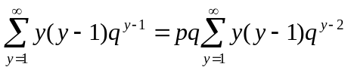= 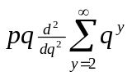= 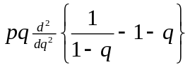 = 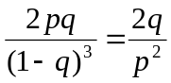. Use this with V(Y) = E[Y(Y–1)] + E(Y) – [E(Y)]².

  - P(Y = y₀) = 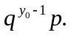 Like Ex. 3.64, maximize this probability by first taking the natural log.

  - 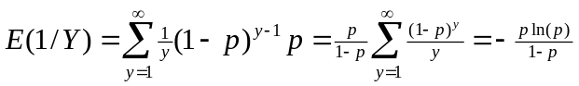.

  - , y = 0, 1, 2, … .

  - 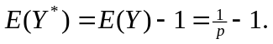 V(Y*) = V(Y – 1) = V(Y).

  - Let Y = # of employees tested until three positives are found. Then, Y is negative binomial with r = 3 and p = .4. P(Y = 10) = 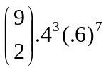 = .06.

  - The total cost is given by 20Y. So, E(20Y) = 20E(Y) = 20 = $50. Similarly, V(20Y) = 400V(Y) = 4500.

  - Let Y = # of trials until this first non–defective engine is found. Then, Y is geometric with p = .9. P(Y = 2) = .9(.1) = .09.

  - From Ex. 3.92:
- P(Y = 5) = 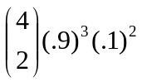 = .04374.
- P(Y ≤ 5) = P(Y = 3) + P(Y = 4) + P(Y = 5) = .729 + .2187 + .04374 = .99144.

  - a. μ = 1/(.9) = 1.11, σ² = (.1)/(.9)2 = .1234.
b. μ = 3/(.9) = 3.33, σ² = 3(.1)/(.9)2 = .3704.

  - From Ex. 3.92 (and the memory–less property of the geometric distribution),
P(Y ≥ 4 | Y > 2) = P(Y > 3 | Y > 2) = P(Y > 1) = 1 – P(Y = 0) = .1.

  - a. Let Y = # of attempts until you complete your call. Thus, Y is geometric with p = .4. Thus, P(Y = 1) = .4, P(Y = 2) = (.6).4 = .24, P(Y = 3) = (.6)².4 = .144.
b. Let Y = # of attempts until both calls are completed. Thus, Y is negative binomial with r = 2 and p = .4. Thus, P(Y = 4) = 3(.4)²(.6)² = .1728.

  - a. Geometric probability calculation: (.8)²(.2) = .128.
b. Negative binomial probability calculation: 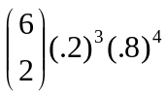 = .049.
c. The trials are independent and the probability of success is the same from trial to trial.

d. μ = 3/.2 = 15, σ² = 3(.8)/(.04) = 60.

  - a. 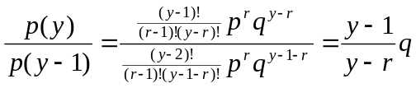
b. If 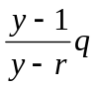 > 1, then yq – q > y – r or equivalently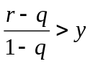. The 2nd result is similar.
c. If r = 7, p = .5 = q, then 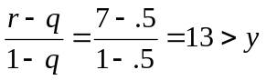.

  - Define a random variable X = y trials before the before the first success, y = r – 1, r, r + 1, … . Then, X = Y – 1, where Y has the negative binomial distribution with parameters r and p. Thus, p(x) = 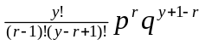, y = r – 1, r, r + 1, … .

  - a. 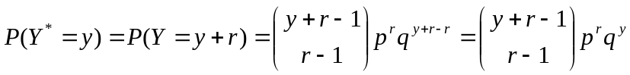, y = 0, 1, 2, … .

b. E(Y*) = E(Y) – r = r/p – r = r/q, V(Y*) = V(Y – r) = V(Y).

  - a. Note that P(Y = 11) = 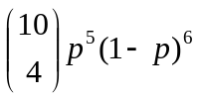. Like Ex. 3.64 and 3.86, maximize this probability by first taking the natural log. The maximum is 5/11.
b. In general, the maximum is r/y₀.

  - Let Y = # of green marbles chosen in three draws. Then. P(Y = 3) = 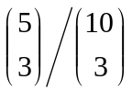 = 1/12.

  - Use the hypergeometric probability distribution with N = 10, r = 4, n = 5. P(Y = 0) = 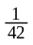.

  - Define the events: A: 1st four selected packets contain cocaine
B: 2nd two selected packets do not contain cocaine

Then, the desired probability is P(A∩B) = P(B|A)P(A). So,
P(A) = 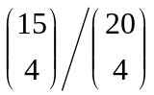 = .2817 and P(B|A) = 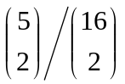 = .0833. Thus,
P(A∩B) = .2817(.0833) = 0.0235.

  - a. The random variable Y follows a hypergeometric distribution. The probability of being chosen on a trial is dependent on the outcome of previous trials.

b. P(Y ≥ 2) = P(Y = 2) + P(Y = 3) = 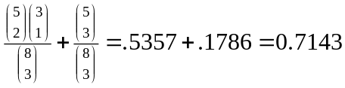.
c. μ = 3(5/8) = 1.875, σ² = 3(5/8)(3/8)(5/7) = .5022, so σ = .7087.

  - Using the results from Ex.103, E(50Y) = 50E(Y) = 50[5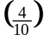] = $100. Furthermore, V(50Y) = 2500V(Y) = 2500[5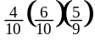] = 1666.67.

  - The random variable Y follows a hypergeometric distribution with N = 6, n = 2, and r = 4.

  - Use the fact that P(at least one is defective) = 1 – P(none are defective). Then, we require P(none are defective) ≤ .2. If n = 8,
P(none are defective) = 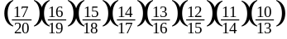 = 0.193.

  - Let Y = # of treated seeds selected.
- P(Y = 4) = 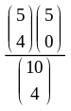 = .0238
- P(Y ≤ 3) = 1 – P(Y = 4) = 1 – = 1 – .0238 = .9762.
- same answer as part (b) above.
  - a. P(Y = 1) = 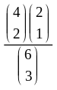 = .6.
b. P(Y ≥ 1) = p(1) + p(2) = 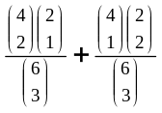 = .8
c. P(Y ≤ 1) = p(0) + p(1) = .8.

  - a. The probability function for Y is p(y) = 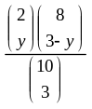, y = 0, 1, 2. In tabular form, this is
y | 0 | 1 | 2
p(y) | 14/30 | 14/30 | 2/30

b. The probability function for Y is p(y) = 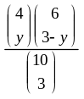, y = 0, 1, 2, 3. In tabular form, this is
y | 0 | 1 | 2 | 3
p(y) | 5/30 | 15/30 | 9/30 | 1/30

  - Let Y = # of malfunctioning copiers selected. Then, Y is hypergeometric with probability function
p(y) = 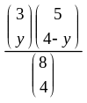, y = 0, 1, 2, 3.
- P(Y = 0) = p(0) = 1/14.
- P(Y ≥ 1) = 1 – P(Y = 0) = 13/14.

  - The probability of an event as rare or rarer than one observed can be calculated according to the hypergeometric distribution, Let Y = # of black members. Then, Y is hypergeometric and P(Y ≤ 1) = 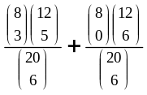 = .187. This is nearly 20%, so it is not unlikely.

  - μ = 6(8)/20 = 2.4, σ² 6(8/20)(12/20)(14/19) = 1.061.

  - The probability distribution for Y is given by

y | 0 | 1 | 2
p(y) | 1/5 | 3/5 | 1/5

  - (Answers vary, but with n =100, the relative frequencies should be close to the probabilities in the table above.)

  - Let Y = # of improperly drilled gearboxes. Then, Y is hypergeometric with N = 20, n = 5, and r = 2.
- P(Y = 0) = .553
- The random variable T, the total time, is given by T = 10Y + (5 – Y) = 9Y + 5. Thus, E(T) = 9E(Y) + 5 = 9[5(2/20)] + 5 = 9.5.
V(T) = 81V(T) = 81(.355) = 28.755, σ = 5.362.

  - Let Y = # of aces in the hand. Then. P(Y = 4 | Y ≥ 3) = 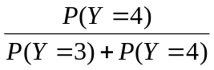. Note that Y is a hypergeometric random variable. So, 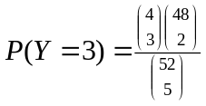 = .001736 and 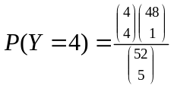 = .00001847. Thus, P(Y = 4 | Y ≥ 3) = .0105.

  - Let the event A = 2nd king is dealt on 5th card. The four possible outcomes for this event are {KNNNK, NKNNK, NNKNK, NNNKK}, where K denotes a king and N denotes a non–king. Each of these outcomes has probability: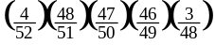. Then, the desired probability is P(A) = 4 = .016.

  - There are N animals in this population. After taking a sample of k animals, making and releasing them, there are N – k unmarked animals. We then choose a second sample of size 3 from the N animals. There are 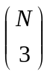 ways of choosing this second sample and there are 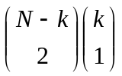 ways of finding exactly one of the originally marked animals. For k = 4, the probability of finding just one marked animal is
P(Y = 1) = 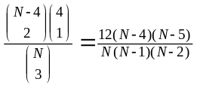.
Calculating this for various values of N, we find that the probability is largest for N = 11 or N = 12 (the same probability is found: .503).

  - a. P(Y = 4) = 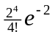= .090.
b. P(Y ≥ 4) = 1 – P(Y ≤ 3) = 1 – .857 = .143 (using Table 3, Appendix III).
c. P(Y < 4) = P(Y ≤ 3) = .857.
d. P(Y ≥ 4 | Y ≥ 2) = 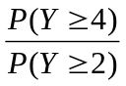 = .143/.594 = .241

  - Let Y = # of customers that arrive during the hour. Then, Y is Poisson with λ = 7.
- P(Y ≤ 3) = .0818.
- P(Y ≥ 2) = .9927.
- P(Y = 5) = .1277

  - If p(0) = p(1), 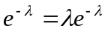. Thus, λ = 1. Therefore, p(2) = 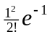 = .1839.

  - Using Table 3 in Appendix III, we find that if Y is Poisson with λ = 6.6, P(Y ≤ 2) = .04. Using this value of λ, P(Y > 5) = 1 – P(Y ≤ 5) = 1 – .355 = .645.

  - Let S = total service time = 10Y. From Ex. 3.122, Y is Poisson with λ = 7. Therefore, E(S) = 10E(Y) = 7 and V(S) = 100V(Y) = 700. Also,
P(S > 150) = P(Y > 15) = 1 – P(Y ≤ 15) = 1 – .998 = .002, and unlikely event.

  - a. Let Y = # of customers that arrive in a given two–hour time. Then, Y has a Poisson distribution with λ = 2(7) = 14 and P(Y = 2) = 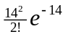.

b. The same answer as in part a. is found.

  - Let Y = # of typing errors per page. Then, Y is Poisson with λ = 4 and P(Y ≤ 4) = .6288.

  - Note that over a one–minute period, Y = # of cars that arrive at the toll booth is Poisson with λ = 80/60 = 4/3. Then, P(Y ≥ 1) = 1 – P(Y = 0) = 1 – e^{– 4/3} = .7364.

  - Following the above exercise, suppose the phone call is of length t, where t is in minutes. Then, Y = # of cars that arrive at the toll booth is Poisson with λ = 4t/3. Then, we must find the value of t such that
P(Y = 0) = 1 – e^{–4t/3} ≥ .4.
Therefore, t ≤ –ln(.6) = .383 minutes, or about .383(60) = 23 seconds.

  - Define: Y₁ = # of cars through entrance I, Y₂ = # of cars through entrance II. Thus, Y₁ is Poisson with λ = 3 and Y₂ is Poisson with λ = 4.

Then, P(three cars arrive) = P(Y₁ = 0, Y₂ = 3) + P(Y₁ = 1, Y₂ = 2)+ P(Y₁ = 2, Y₂ = 1) +
+P(Y₁ = 3, Y₂ = 0).

By independence, P(three cars arrive) = P(Y₁ = 0)P(Y₂ = 3) + P(Y₁ = 1)P(Y₂ = 2)
+ P(Y₁ = 2)P(Y₂ = 1) + P(Y₁ = 3)P(Y₂ = 0).
Using Poisson probabilities, this is equal to 0.0521

  - Let the random variable Y = # of knots in the wood. Then, Y has a Poisson distribution with λ = 1.5 and P(Y ≤ 1) = .5578.

  - Let the random variable Y = # of cars entering the tunnel in a two–minute period. Then, Y has a Poisson distribution with λ = 1 and P(Y > 3) = 1 – P(Y ≤ 3) = 0.01899.

  - Let X = # of two–minute intervals with more than three cars. Therefore, X is binomial with n = 10 and p = .01899 and P(X ≥ 1) = 1 – P(X = 0) = 1 – (1–.01899)¹⁰ = .1745.

  - The probabilities are similar, even with a fairly small n.
y | p(y), exact binomial | p(y), Poisson approximation
0 | .358 | .368
1 | .378 | .368
2 | .189 | .184
3 | .059 | .061
4 | .013 | .015

  - Using the Poisson approximation, λ ≈ np = 100(.03) = 3, so P(Y ≥ 1) = 1 – P(Y = 0) = .9524.

  - Let Y = # of E. coli cases observed this year. Then, Y has an approximate Poisson distribution with λ ≈ 2.4.
- P(Y ≥ 5) = 1 – P(Y ≤ 4) = 1 – .904 = .096.
- P(Y > 5) = 1 – P(Y ≤ 5) = 1 – .964 = .036. Since there is a small probability associated with this event, the rate probably has charged.

  - Using the Poisson approximation to the binomial with λ ≈ np = 30(.2) = 6.
Then, P(Y ≤ 3) = .1512.

  - 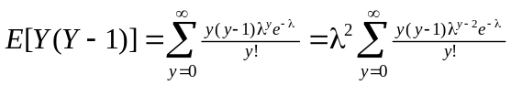. Using the substitution z = y – 2, it is found that E[Y(Y – 1)] = λ². Use this with V(Y) = E[Y(Y–1)] + E(Y) – [E(Y)]² = λ.

  - Note that if Y is Poisson with λ = 2, E(Y) = 2 and E(Y²) = V(Y) + [E(Y)]² = 2 + 4 = 6. So, E(X) = 50 – 2E(Y) – E(Y²) = 50 – 2(2) – 6 = 40.

  - Since Y is Poisson with λ = 2, E(C) = 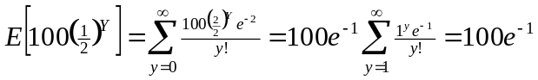.

  - Similar to Ex. 3.139: E(R) = E(1600 – 50Y²) = 1600 – 50(6) = $1300.

  - a. 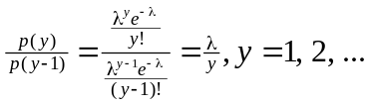
b. Note that if λ > y, p(y) > p(y – 1). If λ > y, p(y) > p(y – 1). If λ = y for some integer y, p(y) = p(y – 1).
c. Note that for λ a non–integer, part b. implies that for y – 1 < y < λ,
p(y – 1) < p(y) > p(y + 1).
Hence, p(y) is maximized for y = largest integer less than λ. If λ is an integer, then p(y) is maximized at both values λ – 1 and λ.

  - Since λ is a non–integer, p(y) is maximized at y = 5.

  - Observe that with λ = 6, p(5) = 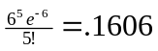, p(6) = 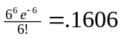.

  - Using the binomial theorem, 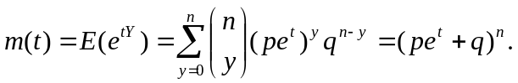

  - 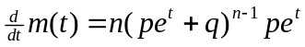. At t = 0, this is np = E(Y).

. At t = 0, this is np²(n – 1) + np.
Thus, V(Y) = np²(n – 1) + np – (np)2 = np(1 – p).

  - The moment–generating function is 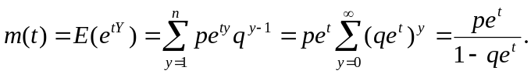

  - 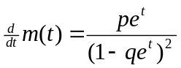. At t = 0, this is 1/p = E(Y).

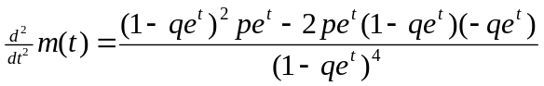. At t = 0, this is (1+q)/p².
Thus, V(Y) = (1+q)/p² – (1/p)² = q/p².

  - This is the moment–generating function for the binomial with n = 3 and p = .6.

  - This is the moment–generating function for the geometric with p = .3.

  - This is the moment–generating function for the binomial with n = 10 and p = .7, so
P(Y ≤ 5) = .1503.

  - This is the moment–generating function for the Poisson with λ = 6. So, μ = 6 and σ = 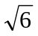 ≈ 2.45. So, P(|Y – μ| ≤ 2σ) = P(μ – 2σ ≤ Y ≤ μ + 2σ) = P(1.1 ≤ Y ≤ 10.9) =
P(2 ≤ Y ≤ 10) = .940.

  - a. Binomial with n = 5, p = .1
b. If m(t) is multiplied top and bottom by ½, this is a geometric mgf with p = ½.
c. Poisson with λ = 2.

  - a. Binomial mean and variance: μ = 1.667, σ² = 1.111.
b. Geometric mean and variance: μ = 2, σ² = 2.
c. Poisson mean and variance: μ = 2, σ² = 2.

  - Differentiate to find the necessary moments:
- E(Y) = 7/3.
- V(Y) = E(Y²) – [E(Y)]² = 6 – (7/3)² = 5/9.
- Since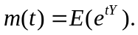Y can only take on values 1, 2, and 3 with probabilities 1/6, 2/6, and 3/6.

  - a. 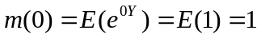.
b. .
c. .

  - a. From part b. in Ex. 3.156, the results follow from differentiating to find the necessary moments.
b. From part c. in Ex. 3.156, the results follow from differentiating to find the necessary moments.

  - The mgf for W is .

  - From Ex. 3.158, the results follow from differentiating the mgf of W to find the necessary moments.

  - a. E(Y*) = E(n – Y) = n – E(Y) = n – np = n(1 – p) = nq. V(Y*) = V(n – Y) = V(Y) = npq.

b.

c. Based on the moment–generating function, Y* has a binomial distribution.

d. The random variable Y* = # of failures.
e. The classification of “success” and “failure” in the Bernoulli trial is arbitrary.

  - Note that 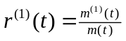, 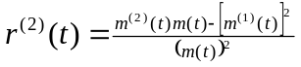. Then, 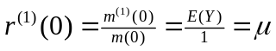. 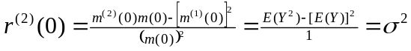.

  - Note that r(t) = 5(e^{t} – 1). Then, 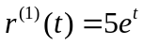and 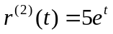. So, 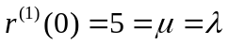 and 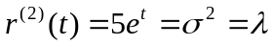.

  - For the binomial, 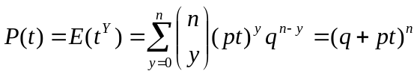. Differentiating with respect to t, 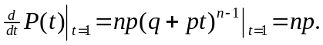

  - For the Poisson, 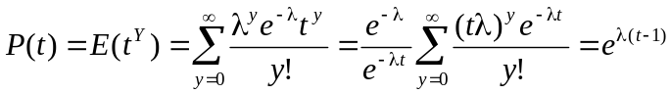. Differentiating with respect to t, 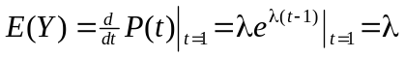 and 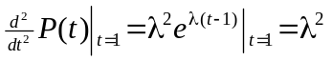 = E[Y(Y – 1)] = E(Y²) – E(Y). Thus, V(Y) = λ.

  - E[Y(Y – 1)(Y – 2)] = 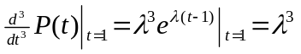= E(Y³) – 3E(Y²) + 2E(Y). Therefore, E(Y³) = λ³ + 3(λ² + λ) – 2λ = λ³ + 3λ² + λ.

  - a. The value 6 lies (11–6)/3 = 5/3 standard deviations below the mean. Similarly, the value 16 lies (16–11)/3 = 5/3 standard deviations above the mean. By Tchebysheff’s theorem, at least 1 – 1/(5/3)² = 64% of the distribution lies in the interval 6 to 16.

b. By Tchebysheff’s theorem, .09 = 1/k², so k = 10/3. Since σ = 3, kσ = (10/3)³ = 10 = C.

  - Note that Y has a binomial distribution with n = 100 and p = 1/5 = .2
- E(Y) = 100(.2) = 20.
- V(Y) = 100(.2)(.8) = 16, so σ = 4.
- The intervals are 20 ± 2(4) or (12, 28), 20 + 3(4) or (8, 32).
- By Tchebysheff’s theorem, 1 – 1/3² or approximately 89% of the time the number of correct answers will lie in the interval (8, 32). Since a passing score of 50 is far from this range, receiving a passing score is very unlikely.

  - a. E(Y) = –1(1/18) + 0(16/18) + 1(1/18) = 0. E(Y²) = 1(1/18) + 0(16/18) + 1(1/18) = 2/18 = 1/9. Thus, V(Y) = 1/9 and σ = 1/3.

b. P(|Y – 0| ≥ 1) = P(Y = –1) + P(Y = 1) = 1/18 + 1/18 = 2/18 = 1/9. According to Tchebysheff’s theorem, an upper bound for this probability is 1/3² = 1/9.

c. Example: let X have probability distribution p(–1) = 1/8, p(0) = 6/8, p(1) = 1/8. Then, E(X) = 0 and V(X) = 1/4.

d. For a specified k, assign probabilities to the points –1, 0, and 1 as p(–1) = p(1) = 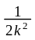 and p(0) = 1 – .

  - Similar to Ex. 3.167: the interval (.48, 52) represents two standard deviations about the mean. Thus, the lower bound for this interval is 1 – ¼ = ¾. The expected number of coins is 400(¾) = 300.

  - Using Tchebysheff’s theorem, 5/9 = 1 – 1/k², so k = 3/2. The interval is 100 ± (3/2)10, or 85 to 115.

  - From Ex. 3.115, E(Y) = 1 and V(Y) = .4. Thus, σ = .63. The interval of interest is 1 ± 2(.63), or (–.26, 2.26). Since Y can only take on values 0, 1, or 2, 100% of the values will lie in the interval. According to Tchebysheff’s theorem, the lower bound for this probability is 75%.

  - a. The binomial probabilities are p(0) = 1/8, p(1) = 3/8, p(2) = 3/8, p(3) = 1/8.

b. The graph represents a symmetric distribution.

c. E(Y) = 3(1/2) = 1.5, V(Y) = 3(1/2)(1/2) = .75. Thus, σ = .866.

d. For one standard deviation about the mean: 1.5 ± .866 or (.634, 2.366)
This traps the values 1 and 2, which represents 7/8 or 87.5% of the probability. This is consistent with the empirical rule.
For two standard deviations about the mean: 1.5 ± 2(.866) or (–.232, 3.232)
This traps the values 0, 1, and 2, which represents 100% of the probability. This is consistent with both the empirical rule and Tchebysheff’s theorem.

  - a. (Similar to Ex. 3.173) the binomial probabilities are p(0) = .729, p(1) = .243, p(2) = .027, p(3) = .001.

b. The graph represents a skewed distribution.

c. E(Y) = 3(.1) = .3, V(Y) = 3(.1)(.9) = .27. Thus, σ = .520.

d. For one standard deviation about the mean: .3 ± .520 or (–.220, .820)
This traps the value 1, which represents 24.3% of the probability. This is not consistent with the empirical rule.
For two standard deviations about the mean: .3 ± 2(.520) or (–.740, 1.34)
This traps the values 0 and 1, which represents 97.2% of the probability. This is consistent with both the empirical rule and Tchebysheff’s theorem.

  - a. The expected value is 120(.32) = 38.4
b. The standard deviation is 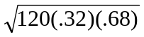= 5.11.
c. It is quite likely, since 40 is close to the mean 38.4 (less than .32 standard deviations away).

  - Let Y represent the number of students in the sample who favor banning clothes that display gang symbols. If the teenagers are actually equally split, then E(Y) = 549(.5) = 274.5 and V(Y) = 549(.5)(.5) = 137.25. Now. Y/549 represents the proportion in the sample who favor banning clothes that display gang symbols, so E(Y/549) = .5 and V(Y/549) = .5(.5)/549 = .000455. Then, by Tchebysheff’s theorem,
P(Y/549 ≥ .85) ≤ P(|Y/549 – .5| ≥ .35) ≤ 1/k²,
where k is given by kσ = .35. From above, σ = .02134 so k = 16.4 and 1/(16.4)² = .0037. This is a very unlikely result. It is also unlikely using the empirical rule. We assumed that the sample was selected randomly from the population.

  - For C = 50 + 3Y, E(C) = 50 + 3(10) = $80 and V(C) = 9(10) = 90, so that σ = 9.487. Using Tchebysheff’s theorem with k = 2, we have P(|Y – 80| < 2(9.487)) ≥ .75, so that the required interval is (80 – 2(9.487), 80 + 2(9.487)) or (61.03, 98.97).

  - Using the binomial, E(Y) = 1000(.1) = 100 and V(Y) = 1000(.1)(.9) = 90. Using the result that at least 75% of the values will fall within two standard deviation of the mean, the interval can be constructed as 100 ± 2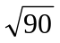, or (81, 119).

  - Using Tchebysheff’s theorem, observe that
.
Therefore, to find P(Y ≥ 350) ≤ 1/k², we solve 150 + k(67.081) = 350, so k = 2.98. Thus, P(Y ≥ 350) ≤ 1/(2.98)² = .1126, which is not highly unlikely.

  - Number of combinations = 26(26)(10)(10)(10)(10) = 6,760,000. Thus,
E(winnings) = 100,000(1/6,760,000) + 50,000(2/6,760,000) + 1000(10/6,760,000) = $.031, which is much less than the price of the stamp.

  - Note that P(acceptance) = P(observe no defectives) = 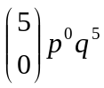. Thus:
p = Fraction defective | P(acceptance)
0 | 1
.10 | .5905
.30 | .1681
.50 | .0312
1.0 | 0

  - OC curves can be constructed using points given in the tables below.
a. Similar to Ex. 3.181: P(acceptance) = 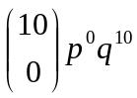. Thus,
p | 0 | .05 | .10 | .30 | .50 | 1
P(acceptance) | 1 | .599 | .349 | .028 | .001 | 0

b. Here, P(acceptance) = 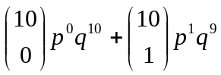. Thus,

p | 0 | .05 | .10 | .30 | .50 | 1
P(acceptance) | 1 | .914 | .736 | .149 | .01 | 0

c. Here, P(acceptance) = 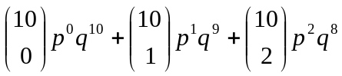. Thus,

p | 0 | .05 | .10 | .30 | .50 | 1
P(acceptance) | 1 | .988 | .930 | .383 | .055 | 0

  - Graph the two OC curves with n = 5 and a = 1 in the first case and n = 25 and a = 5 in the second case.

- By graphing the OC curves, it is seen that if the defectives fraction ranges from p = 0 to p = .10, the seller would want the probability of accepting in this interval to be a high as possible. So, he would choose the second plan.
- If the buyer wishes to be protected against accepting lots with a defective fraction greater than .3, he would want the probability of acceptance (when p > .3) to be as small as possible. Thus, he would also choose the second plan.
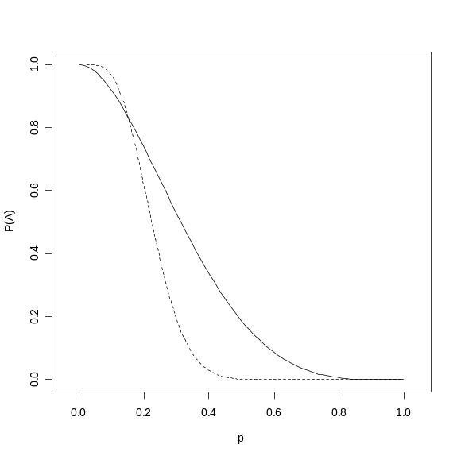
The above graph illustrates the two OC curves. The solid lie represents the first case and the dashed line represents the second case.

  - Let Y = # in the sample who favor garbage collect by contract to a private company. Then, Y is binomial with n = 25.
- If p = .80, P(Y ≥ 22) = 1 – P(Y ≤ 21) = 1 – .766 = .234,
- If p = .80, P(Y = 22) = .1358.
- There is not strong evidence to show that the commissioner is incorrect.

  - Let Y = # of students who choose the numbers 4, 5, or 6. Then, Y is binomial with n = 20 and p = 3/10.
- P(Y ≥ 8) = 1 – P(Y ≤ 7) = 1 – .7723 = .2277.
- Given the result in part a, it is not an unlikely occurrence for 8 students to choose 4, 5 or 6.

  - The total cost incurred is W = 30Y. Then,
E(W) = 30E(Y) = 30(1/.3) = 100, V(W) = 900V(Y) = 900(.7/.3²) = 7000.
Using the empirical rule, we can construct a interval of three standard deviations about the mean: 100 ± 3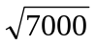, or (151, 351).

  - Let Y = # of rolls until the player stops. Then, Y is geometric with p = 5/6.
- P(Y = 3) = (1/6)²(5/6) = .023.
- E(Y) = 6/5 = 1.2.
- Let X = amount paid to player. Then, X = 2^{Y–1}.
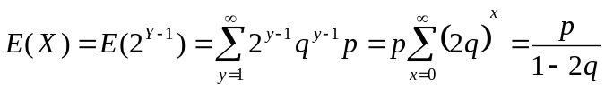, since 2q < 1. With p = 5/6, this is $1.25.
  - The result follows from 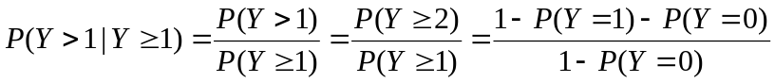.

  - The random variable Y = # of failures in 10,000 starts is binomial with n = 10,000 and
p = .00001. Thus, P(Y ≥ 1) = 1 – P(Y = 0) = 1 – (.9999)¹⁰⁰⁰⁰ = .09516.
Poisson approximation: 1 – e^{–.1} = .09516.

  - Answers vary, but with n = 100, should be quite close to μ = 1.

  - Answers vary, but with n = 100, s² should be quite close to σ² = .4.

  - Note that p(1) = p(2) = … p(6) = 1/6. From Ex. 3.22, μ = 3.5 and σ² = 2.9167. The interval constructed of two standard deviations about the mean is (.08, 6.92) which contains 100% of the possible values for Y.

  - Let Y₁ = # of defectives from line I, Y₂ is defined similarly. Then, both Y₁ and Y₂ are binomial with n = 5 and defective probability p. In addition, Y₁ + Y₂ is also binomial with n = 10 and defective probability p. Thus,

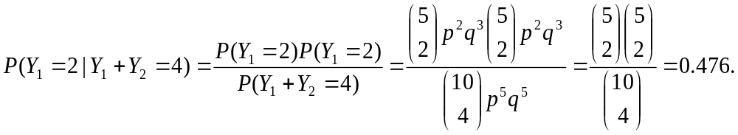
Notice that the probability does not depend on p.

  - The possible outcomes of interest are:
WLLLLLLLLLL, LWLLLLLLLLL, LLWLLLLLLLL
So the desired probability is .1(.9)¹⁰ + .9(.1)(.9)⁹ + (.9)²(.1)(.9)⁸ = 3(.1)(.9)¹⁰ = .104.

  - Let Y = # of imperfections in one–square yard of weave. Then, Y is Poisson with λ = 4.
- P(Y ≥ 1) = 1 – P(Y = 0) = 1 – e^{–4} = .982.
- Let W = # of imperfections in three–square yards of weave. Then, W is Poisson with λ = 12. P(W ≥ 1) = 1 – P(W = 0) = 1 – e^{–12}.

  - For an 8–square yard bolt, let X = # of imperfections so that X is Poisson with λ = 32. Thus, C = 10X is the cost to repair the weave and
E(C) = 10E(X) = $320 and V(C) = 100V(X) = 3200.

  - a. Let Y = # of samples with at least one bacteria colony. Then, Y is binomial with n = 4 and p = P(at least one bacteria colony) = 1 – P(no bacteria colonies) = 1 – e^{–2} = .865 (by the Poisson). Thus, P(Y ≥ 1) = 1 – P(Y = 0) = 1 – (.135)⁴ = .9997.

b. Following the above, we require 1 – (.135)^{n} = .95 or (.135)^{n} = .05. Solving for n, we have 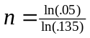 = 1.496, so take n = 2.

  - Let Y = # of neighbors for a seedling within an area of size A. Thus, Y is Poisson with λ = A*d, where for this problem d = 4 per square meter.
- Note that “within 1 meter” denotes an area A = π(1 m)² = π m². Thus, P(Y = 0) = e^{–4π}.
- “Within 2 meters” denotes an area A = π(2 m)² = 4π m². Thus,
P(Y ≤ 3) = P(Y = 0) + P(Y = 1) + P(Y = 2) + P(Y = 3) = 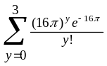.

  - a. Using the binomial model with n = 1000 and p = 30/100,000, let λ ≈ np = 1000(30/100000) = .300 for the Poisson approximation.

b. Let Y = # of cases of IDD. P(Y ≥ 2) = 1 – P(Y = 0) – P(Y = 1) = 1 – .963 = .037.

  - Note that
.

Expanding the above multinomial (but only showing the first three terms gives

The coefficients agree with the first and second moments for the binomial distribution.

  - From Ex. 103 and 106, we have that μ = 100 and σ = 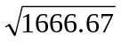 = 40.825. Using an interval of two standard deviations about the mean, we obtain 100 ± 2(40.825) or
(18.35, 181.65)

  - Let W = # of drivers who wish to park and W′ = # of cars, which is Poisson with mean λ. a. Observe that
P(W = k) = 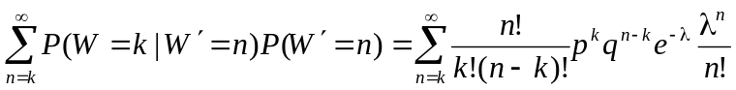

= 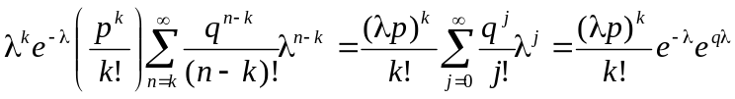
= 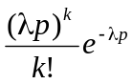, k = 0, 1, 2, … .
Thus, P(W = 0) = 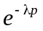.

b. This is a Poisson distribution with mean λp.

  - Note that Y(t) has a negative binomial distribution with parameters r = k, p = e^{–λt}.
- E[Y(t)] = ke^{λt}, V[Y(t)] = 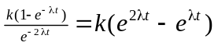.

- With k = 2, λ = .1, E[Y(5)] = 3.2974, V[Y(5)] = 2.139.

  - Let Y = # of left–turning vehicles arriving while the light is red. Then, Y is binomial with n = 5 and p = .2. Thus, P(Y ≤ 3) = .993.

  - One solution: let Y = # of tosses until 3 sixes occur. Therefore, Y is negative binomial where r = 3 and p = 1/6. Then, P(Y = 9) = 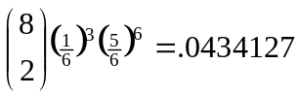. Note that this probability contains all events where a six occurs on the 9th toss. Multiplying the above probability by 1/6 gives the probability of observing 4 sixes in 10 trials, where a six occurs on the 9th and 10th trial: (.0424127)(1/6) = .007235.

  - Let Y represent the gain to the insurance company for a particular insured driver and let P be the premium charged to the driver. Given the information, the probability distribution for Y is given by:
y | p(y)
P | .85
P – 2400 | .15(.80) = .12
P – 7200 | .15(.12) = .018
P – 12,000 | .15(.08) = .012

If the expected gain is 0 (breakeven), then:
E(Y) = P(.85) + (P – 2400).12 + (P – 7200).018 + (P – 12000).012 = 0, so P = $561.60.

  - Use the Poisson distribution with λ = 5.
- p(2) = .084, P(Y ≤ 2) = .125.
- P(Y > 10) = 1 – P(Y ≤ 10) = 1 – .986 = .014, which represents an unlikely event.

  - If the general public was split 50–50 in the issue, then Y = # of people in favor of the proposition is binomial with n = 2000 and p = .5. Thus,

E(Y) = 2000(.5) = 1000 and V(Y) = 2000(.5)(.5) = 500.

Since σ = 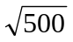 = 22.36, observe that 1373 is (1373 – 1000)/22.36 = 16.68 standard deviations above the mean. Such a value is unlikely.

  - Let Y = # of contracts necessary to obtain the third sale. Then, Y is negative binomial with r = 3, p = .3. So, P(Y < 5) = P(Y = 3) + P(Y = 4) = .3³ + 3(.3)³(.7) = .0837.

  - In Example 3.22, λ = μ = 3 and σ² = 3 and that σ = 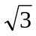 = 1.732. Thus,
= P(Y ≤ 6) = .966. This is consistent with the empirical rule (approximately 95%).

  - There are three scenarios:
- if she stocks two items, both will sell with probability 1. So, her profit is $.40.
- if she stocks three items, two will sell with probability .1 (a loss of .60) and three will sell with probability .9. Thus, her expected profit is (–.60).1 + .60(.9) = $.48.
- if she stocks four items, two will sell with probability .1 (a loss of 1.60), three will sell with probability .4 (a loss of .40), and four will sell with probability .5 (a gain of .80. Thus, her expected profit is (–1.60).1 + (–.40).4 + (.80).5 = $.08

So, to maximize her expected profit, stock three items.

  - Note that: 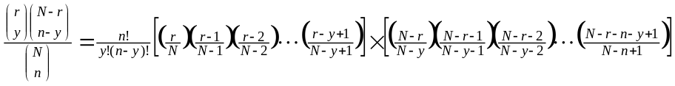. In the first bracketed part, each quotient in parentheses has a limiting value of p. There are y such quotients. In the second bracketed part, each quotient in parentheses has a limiting value of 1 – p = q. There are n – y such quotients, Thus,
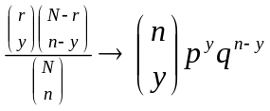 as N → ∞

  - a. The probability is p(10) = 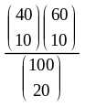 = .1192 (found by dhyper(10, 40, 60, 20) in R).
b. The binomial approximation is 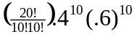 = .117, a close value to the above (exact) answer.

  - Define: A = accident next year B = accident this year C = safe driver

Thus, P(C) = .7, P(A|C) = .1 = P(B|C), and 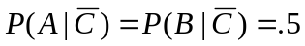. From Bayes’ rule,
P(C|B) = 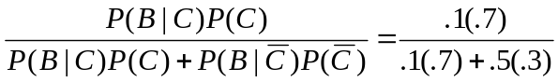 = 7/22.

Now, we need P(A|B). Note that since 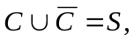 this conditional probability is equal to

, or
= 7/22(.1) + 15/22(.5) = .3727.

So, the premium should be 400(.3727) = $149.09.

  - a. Note that for (2), there are two possible values for N₂, the number of tests performed: 1 and k + 1. If N₂ = 1, all of the k people are healthy and this probability is (.95)^{k}. Thus, P(N₂ = k + 1) = 1 – (.95)^{k}. Thus, E(N₂) = 1(.95)^{k} + (k + 1)(1 – .95^{k}) = 1 + k(1 – .95^{k}).
This expectation holds for each group, so that for n groups the expected number of tests is n[1 + k(1 – .95^{k})].

b. Writing the above as g(k) = 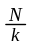[1 + k(1 – .95^{k})], where n = , we can minimize this with respect to k. Note that g′(k) = 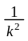 + (.95^{k})ln(.95), a strictly decreasing function. Since k must be an integer, it is found that g(k) is minimized at k = 5 and g(5) = .4262.

c. The expected number of tests is .4262N, compared to the N tests is (1) is used. The savings is then N – .4262N = .5738N.

  - a. P(Y = n) = 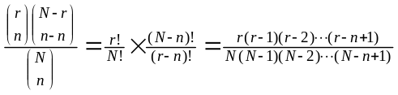.
b. Since for integers a > b, 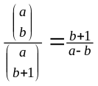, apply this result to find that
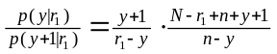 and 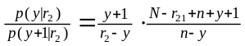.

With r₁ < r₂, it follows that 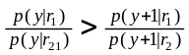.

c. Note that from the binomial theorem, 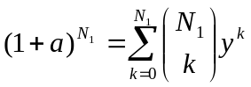. So,
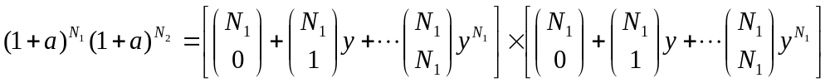=

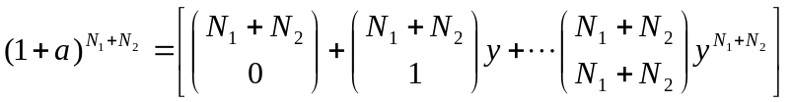. Since these are equal, the coefficient of every y^{n} must be equal. In the second equality, the coefficient is
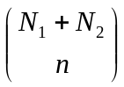.
In the first inequality, the coefficient is given by the sum
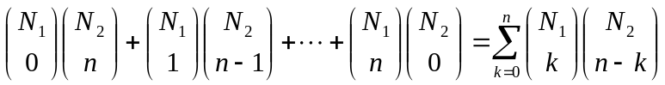, thus the relation holds.

d. The result follows from part c above.

  - 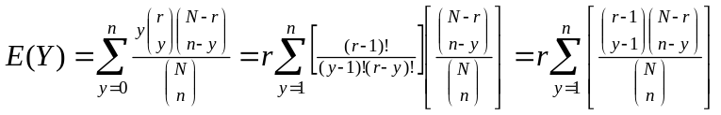. In this sum, let x = y – 1:
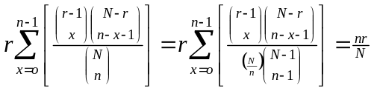.

  - 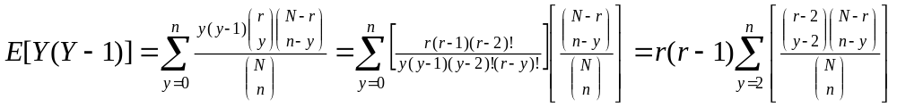. In this sum, let x = y – 2 to obtain the expectation 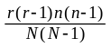. From this result, the variance of the hypergeometric distribution can also be calculated.

